Staff Equality Monitoring Report 2020-21

Executive Summary

This is the tenth annual staff equality monitoring report produced by the Equality and Diversity Unit and follows largely the same format as the previous reports to allow comparison between years. This report supports the University’s obligations to publish annual staff equality monitoring data as part of the Public Sector Equality Duty (PSED) under the Equality Act 2010.

The publishing cycle reflects the previous academic cycle (August 2020 –July 2021).

The report shows the following important points, changes and challenges:
- The Key Performance Indicator set in the new University strategy has three diversity components. All three elements have seen increases since setting these last year - senior women (33.2%, increase by 0.2%), declared disability (4.9%, an increase of 0.5%) and UK Black, Asian and Minority Ethnic (BAME) representation (4.5%, an increase by 0.4%).
- There has been a significant increase in the percentage of Technical and Specialist roles in the University – this is reflected in the diversity data for this job family, who are now, younger, with increases in BAME and Lesbian, Gay and Bisexual representation.
- The overall age profile of the University is changing – moving from a bell curve in previous years to a peak in 26–35-year-olds. This was usual in the Colleges of MVLS and Science and Engineering from previous reports, but it is now also the case in Arts and Social Sciences.
- There has been a notable increase in disability declarations – 0.5% increase since 2019-20, with a 3.6% increase in staff declaring a mental health condition. In addition, there has been a 3.6% increase in colleagues choosing the ‘Prefer not to say’ option – this may indicate colleagues are responding to requests to complete their diversity data.
- There are higher percentages of colleagues resigning within the period of the report following a period of Maternity Leave. This is being investigated to understand any potential patterns associated with this.
- There continues to be a high percentage of colleague who do not declare their ethnicity.
- The percentage of BAME colleagues on contract type ‘O – open-ended with a funding end date’ has increased 2.4% since the last report.
- There are still significant disparities between the application and success rate of BAME applicants; this is subject to a separate detailed analysis as part of the Understanding Racism Transforming University Culture Action Plan.
- The recruitment data set had a significant number of applicants with no diversity data – we will address this with Recruitment colleagues.
- There has been a three-fold increase in staff who have some level of proficiency in BSL.
- The case management data includes information on ethnicity and disability, as a response to the University’s Understanding Racism Transforming University Culture Report.

Introduction

The Staff Equality Monitoring Report allows the University to have a standard base for all staff equality information across the organisation. This report meets one of the University’s obligations under the Public Sector Equality Duty (PSED).

The aim of this report is to provide transparent data for all functions in the institution to use when equality information is required, such as when conducting Equality Impact Assessments (EIA).

Structure

This report has been structured to provide a ‘Whole University’ overview by all the main protected characteristics plus full/part time working, and maternity leave followed by specific sections on Age, Disability, Ethnicity, Sex and Sexual Orientation with a breakdown of data by the following:
- College
- Grade 10 staff
- Job Family Profiles
- Grade
- Full/Part Time
- Contract Type
- Nationality
- Recruitment – by all applicants and successful applicants

We have not provided a further breakdown beyond ‘Whole University’ on data for religion and belief as the proportion of staff answering these questions is too small to give meaningful information.

Further information has then been provided, by Sex, on:
- Academic Promotions
- Regrading for Professional & Support Staff
- Case management

Information on Sickness Absences has been provided, by Age, Disability, Ethnicity, Sex, and Sexual Orientation.

Notes and definitions

This report is based on a census date of 31 July 2021, unless otherwise stated. This date captures staff at their grade prior to any promotions which take effect on 1 August. Percentages have been used, as there are some instances where numbers are very small and using actual numbers carries a risk of identifying individual staff. Overall proportions for each of the sections have been provided in Tables 1-6 below.

Whole University - Total head count is 9380 (up 689 on last year). This is the head count for all staff in the University; those with multiple contracts are only counted once. The three previous year’s total headcount figures were 7655 (2017-18) and 8198 (2018-19) and 8691 (2019-20).
College/University Services Split
When using the term ‘By College’ later in this report University Services is also included.

Table 1 - College | %2018-19 | %2019-20 | %2020-21
Arts | 8% | 8.3% | 7.9%
MVLS | 28.5% | 30.2% | 32.9%
Science and Engineering | 20% | 19.7% | 19.5%
Social Sciences | 14.5% | 14.8% | 15.7%
University Services | 29% | 27.0% | 24.0%

Job Family Profile
Some members of the Senior Management Group (SMG) are classed as ‘Research & Teaching’ or ‘Clinical’ under the Job Family profile. For reporting purposes these have been moved into SMG, and the original Job Family figures have been amended accordingly.

Table 2 - Job Family | %2018-19 | %2019-20 | %2020-21
Clinical | 3.3% | 3.4% | 3.3%
Management, Professional and Administrative (MPA) | 32.6% | 28.2% | 27.5%
Operational | 10.1% | 9.9% | 8.3%
Research & Teaching | 45.4% | 48.5% | 47.4%
SMG | 0.2% | 0.2% | 0.2%
Technical & Specialist | 8.4% | 9.8% | 13.4%

By Full/Part Time
All staff who work less than one FTE are considered Part Time.

Table 3 - Full Time / Part Time | %2018-19 | %2019-20 | %2020-21
Full Time = FTE 1.0 | 64.5% | 63.6% | 65.5%
Part Time = FTE - 0 + anything < 1.0 | 35.5% | 36.4% | 34.5%

By Contract Type
The contract types are as follows;
F = Fixed term as per FT & OE Contract policy
O = Open ended with funding end date
P = Open ended + Permanent in Temporary Fixed Term Appointment
S = Fixed term - SOSR e.g. Maternity leave cover

Table 4 - Contract Type | %2018-19 | %2019-20 | %2020-21
F = (F) Fixed term | 20.2% | 22.8% | 29.1%
O = (O) Open ended with funding end date | 18.0% | 17.4% | 15.6%
P = (P) Open ended + (C) Permanent in Temporary Fixed Term Appointment (Head of College/Principal/Vice Principal roles etc.) | 60.4% | 58.7% | 54.2%
S = (S) Fixed term - SOSR e.g. Maternity leave cover | 1.3% | 1.2% | 1.1%
Grade Grouping
Table 5 - Grade Grouping | % 2018-19 | % 2019-20 | % 2020-21
Grade 1 | 4.4% | 4.1% | 2.5%
Grade 2 | 4.0% | 3.9% | 4.2%
Grade 3 | 4.0% | 4.7% | 6.0%
Grade 4 | 5.8% | 4.9% | 4.9%
Grade 5 | 13.9% | 14.8% | 15.7%
Grade 6 | 18.5% | 18.4% | 19.6%
Grade 7 | 17.8% | 17.1% | 16.6%
Grade 8 | 12.9% | 12.8% | 12.5%
Grade 9 | 7.9% | 8.1% | 7.6%
Grade 10 (see Table 6 for definition) | 7.0% | 7.4% | 6.7%
Clinical | 3.3% | 3.5% | 3.3%
Other | 0.5% | 0.4% | 0.5%

Table 6 – Grade 10 staff  (based on Actual Grade Description) | % 2018-19 | % 2019-20 | % 2020-21
Professor & Equivalent MRC Grades | 88.0% | 88.5% | 88.6%
Senior Administrative Group | 9.4% | 9.3% | 8.9%
Senior Management Group (SMG) | 2.6% | 2.2% | 2.5%

Age
Two charts are provided for the whole University age data, using 5-year groupings and then 10-year age groupings. For all subsequent charts, the age data is provided using the 10-year age groupings only.

Disability
Two charts have been provided for the whole University disability data, whether staff have stated they have a disability, and then by impairment category. For all subsequent charts the disability data is only provided by whether staff have stated they have a disability or not. Disability statistics include colleagues who have self-identified as ‘disabled’, as well as those who have provided details of an impairment or long-term health condition, whether they have self-identified as ‘disabled’ or not.

Ethnicity
Two charts have been provided for the whole University ethnicity data. For all subsequent charts all ethnic minority categories have been combined into Black, Asian or Minority Ethnic (BAME).

The nomenclature Black, Asian and Minority Ethnic (BAME) was introduced in the 2016-17 report as agreed at the time by members of the University’s Race Equality Group. The University understands this is not a collective experience, however as numbers are small we cannot currently present the data in smaller subsets.

Maternity
This outlines the percentage who returned to work, the percentage still on leave and due to return, those whose contract ended within the period and those who resigned within the reporting period.
Gender Reassignment
In order to collect information in relation the protected characteristic of gender reassignment the University uses the HESA recommended question ‘Does your gender identity match your sex as registered at birth?'. Responses are based on the staff member’s own self-assessment. Due to the wording of the HESA recommended question, it is possible people who identify as Non-binary may be included in the statistics.

Nationality
This is based on information provided by staff about their right to work in the UK. For the purpose of this report, we have used the following categories: UK, EU/EEA and International.

Sexual Orientation
For the purposes of this report, the sexual orientation categories of Lesbian, Gay and Bisexual have been combined and shown as LGB. The whole University data shows the full breakdown, including where information has not been declared. For all subsequent charts, only rates of declared sexual orientation or ‘prefer not to say’ data is provided. This is the fourth year the University has reported this level of information. Future reports will allow more detailed analysis as the University builds trend data on this community of staff.

Recruitment - Applications and Successful Applicants
The census date is based on the date the post was first advertised, 01 August 2020 – 31 July 2021. The information excludes direct appointments. Some roles have more than one post available and so have more than one successful applicant. Data is provided for applicants and successful applicants. The data excludes those who withdrew during the application process or prior to an offer decision.

We continue to have high numbers of instances where we receive no monitoring data from applicants, this is recorded as ‘Unknown’ in the data set. We will work with the University’s Recruitment Team to understand the causes and engage with them to seek and implement solutions to minimise this in the future.

Case Management
This section provides data on formal employment related procedures - Managing Attendance (previously known as Capability), Discipline and Grievance during the report period
01 August 2020 – 31 July 2021. Data is provided by Sex, Disability and Ethnicity, the latter two for the first time as requested by EDSC in response to the University’s Understanding Racism Transforming University Culture report.

Additionally, within this section data is provided on Sickness Absences. Figures are based on staff who have been absent for 20 or more continuous working days between 01 August 2020 – 31 July 2021, with charts provided by Age, Disability, Ethnicity, Sex and Sexual Orientation.

Academic Promotions and Professional & Support Staff Regrading
The data for promotion is only provided by Sex as further disaggregation carries a risk of identifying individual staff.

Pay Gap Information
In accordance with the Public Sector Equality Duties, the Gender Pay Gap and Equal Pay information for Disability and Ethnicity are provided in line with our legislative requirements in a separate report.

Whole University Profile

Age
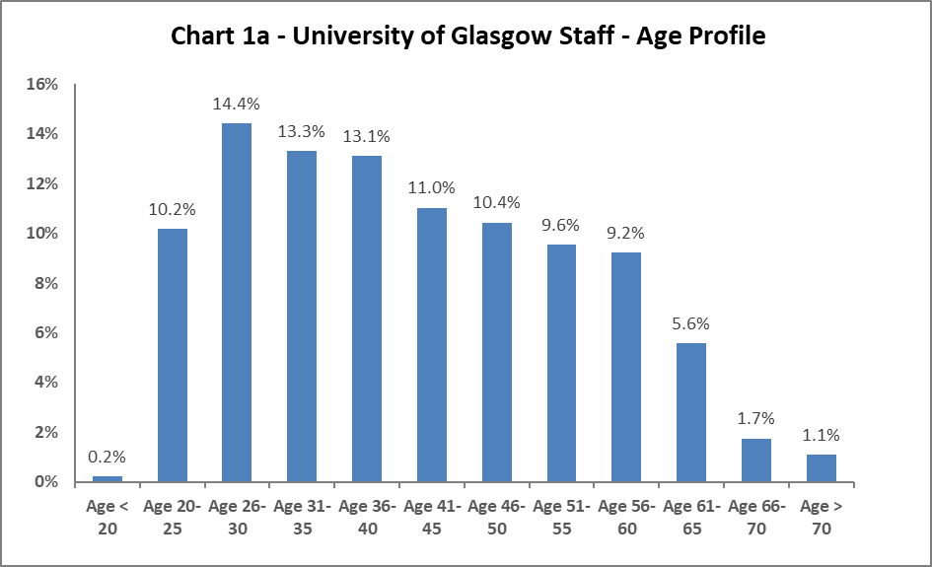

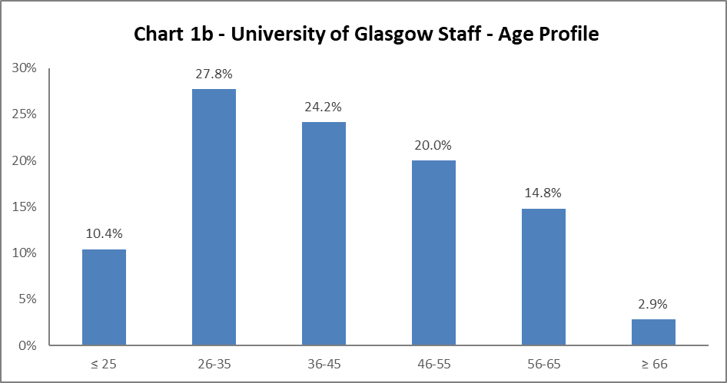

The University's age profile has changed during 2020-21, with a 2% increase in colleagues aged between 26-30, reflected in Chart 1a, and 26-35 in Chart 1b. Prior to this, the University had a bell curve age demographic, but this shows the University age profile is getting younger. Reflecting this there has been a gradual decrease in all other age ranges, except for 66+, which had steadily increased by 0.5% for the last 5 years.

Disability

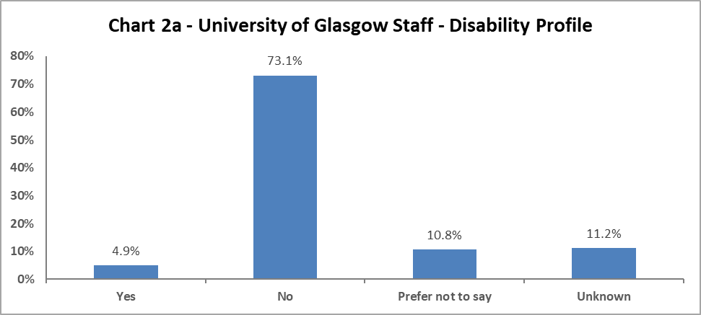

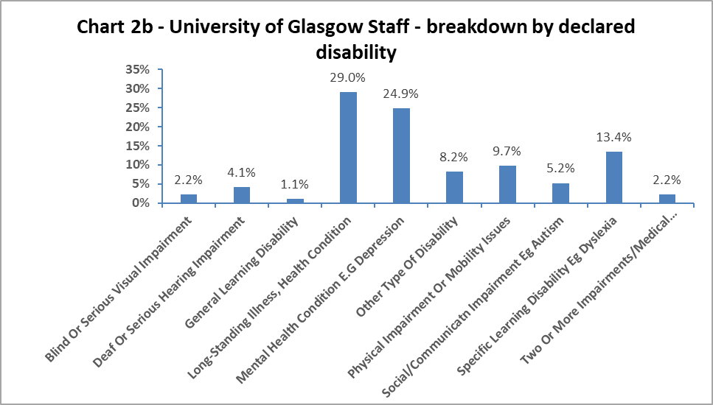

Chart 2a above shows 4.9% of colleagues have declared a disability, this is a 0.5% increase since 2019-20. In addition, there has been a 3.6% increase in colleagues stating ‘Prefer not to say’ and a 6.1% decrease in staff in the ‘Unknown’ category. The data implies that colleagues are more confident to declare to the University, even if this is to state they would prefer not to declare either way.

When considering impairment type, in Chart 2b, the largest cohort of staff has a longstanding illness or health condition, although this has decreased since 2019-20 by 2.5%. The next highest category is colleagues with a mental health condition, which has increased from 2019-20 by 3.6%. There has also been an increase of over 2.3% in colleagues with a physical impairment or mobility issue. Across other impairments there has been minor increases (approx. 1%) in a range of impairments – specific learning disabilities, social/communication impairments and blind/serious visual impairments.

Marital Status

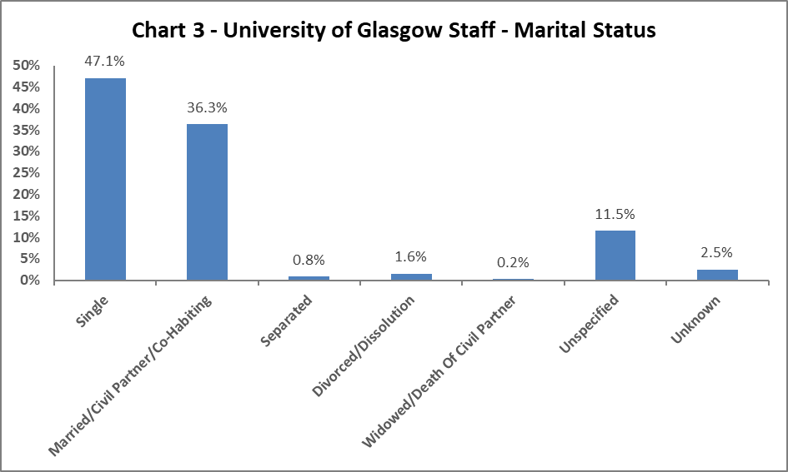

Chart 3 shows single colleagues represent 47.1% of the staff population. This has risen steadily from 31.5% in 2013-14, with a corresponding drop (from 52.1% to 36.3%) in Married/Civil Partnership/Co-habiting colleagues.

Full Time/Part Time

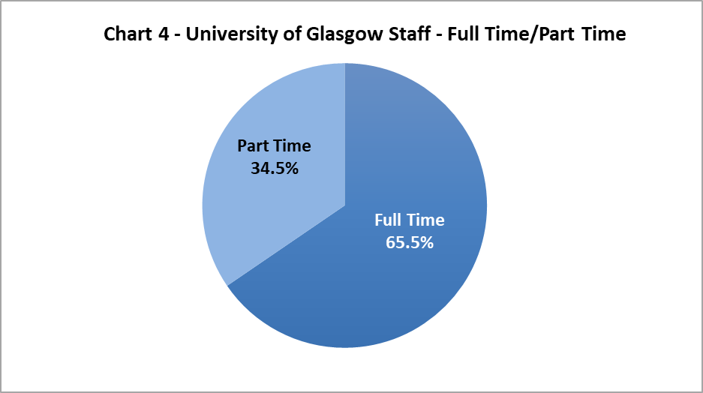

Chart 4 shows approximately two thirds of University colleagues working full time and one third working part time. The Part Time staff has dropped by 1.9% for the first time in several years.

Nationality

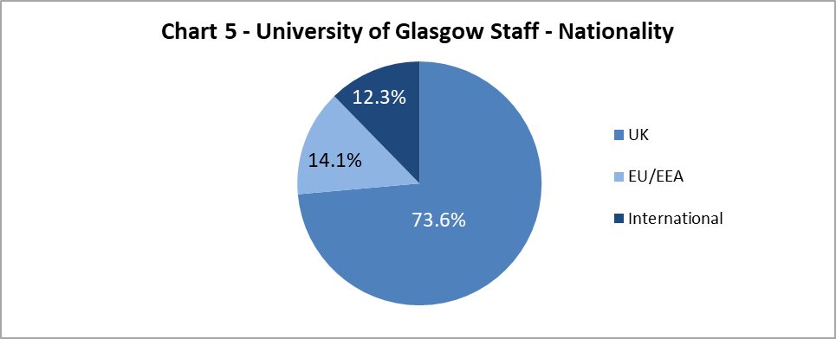

The data shows a 1.3% increase in colleagues from International backgrounds, from 11% in 2019-20. The EU/EAA colleagues have marginally reduced by 0.3%, and UK colleagues have reduced by 0.9%.

Ethnicity

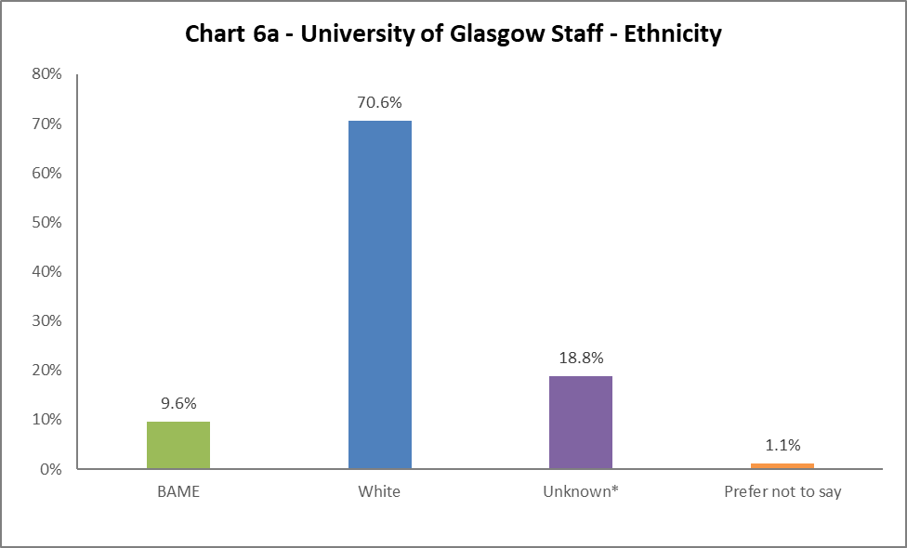

Chart 6a shows 9.6% of University colleagues are from a Black, Asian or Minority Ethnic (BAME) background, a 1% decrease from 2019-20. There has been a 2.6% decrease of colleagues from White backgrounds, this a consecutive decrease of over 5% in the last two years. However, there has also been a 1.6% increase in ‘Unknown’. The full ethnic breakdown is provided in Chart 6b on the next page.

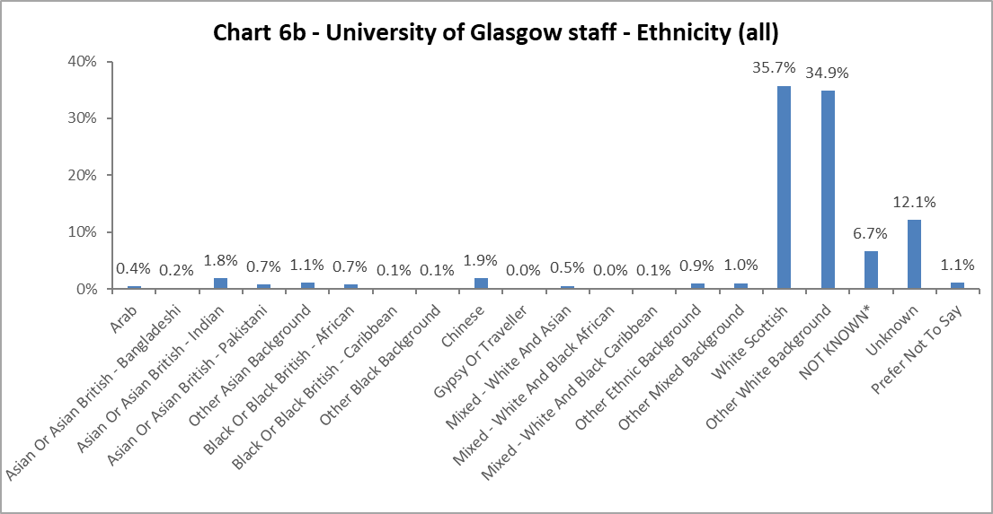

Religion and Belief

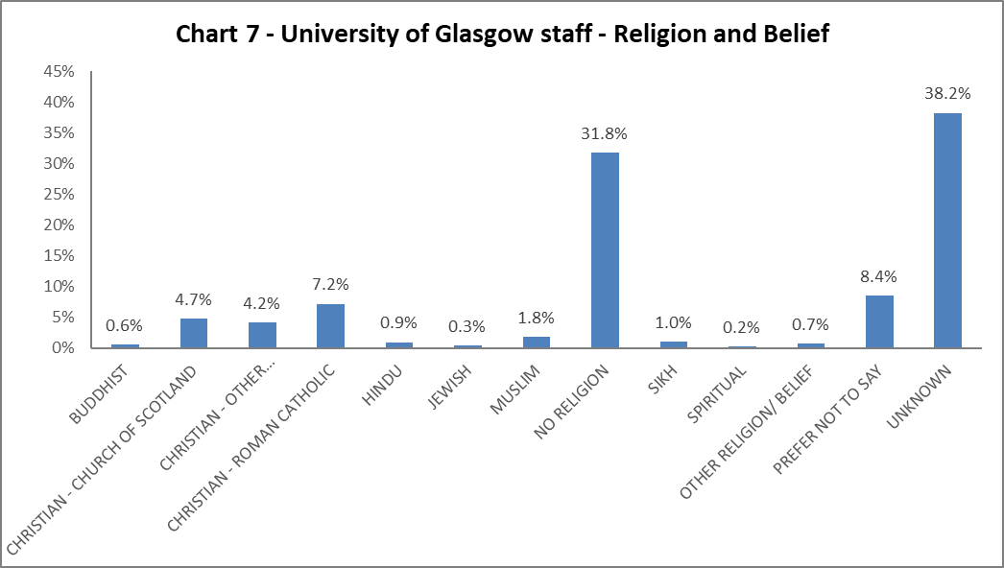
The largest component of staff continues to state they have no religion. There has been a slight rise in staff stating they are Christian by 0.3%; of those the largest proportion state they are Roman Catholic. There has been an increase of Muslim colleagues by 0.6%. All other faiths have seen minor fluctuations.

Sex
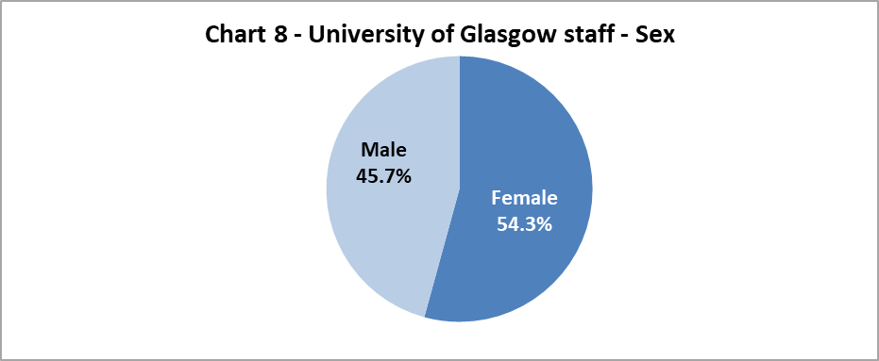

Chart 8 shows the proportion of colleagues by Sex, this only changed by 0.3% between the sexes since 2019-20.

Sexual Orientation

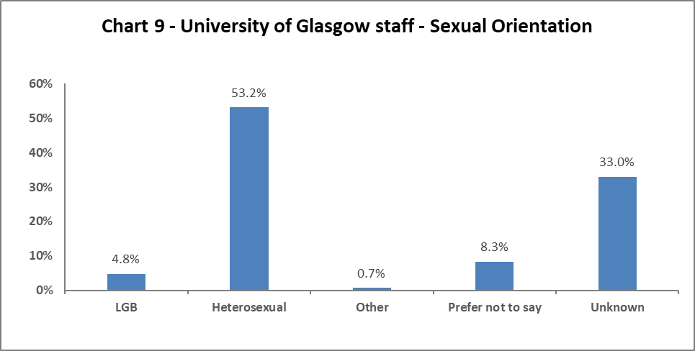

Chart 9 shows the percentage of colleagues who identify as Lesbian, Gay or Bisexual – this has increased by 0.8% from 2019-20. There have only been minor fluctuations in the other sexual orientation categories.

Maternity Leave

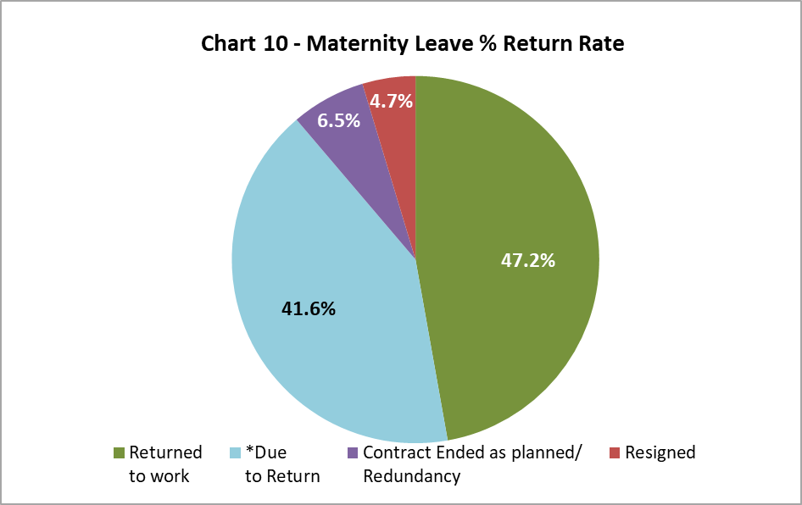

There has been an increase of women resigning post maternity leave from 2% in 2019-20 to 4.7% in 2020-21. Further investigation would be required to understand reasons behind this. There has also been a marked increase in the percentage of women whose contract has ended as planned during maternity leave – increased by 5% from 2019-20.

Gender Reassignment

23 staff responded negatively to the gender identity question:
‘Is your gender identity the same as the sex registered at birth?’

Profile by Age

By College

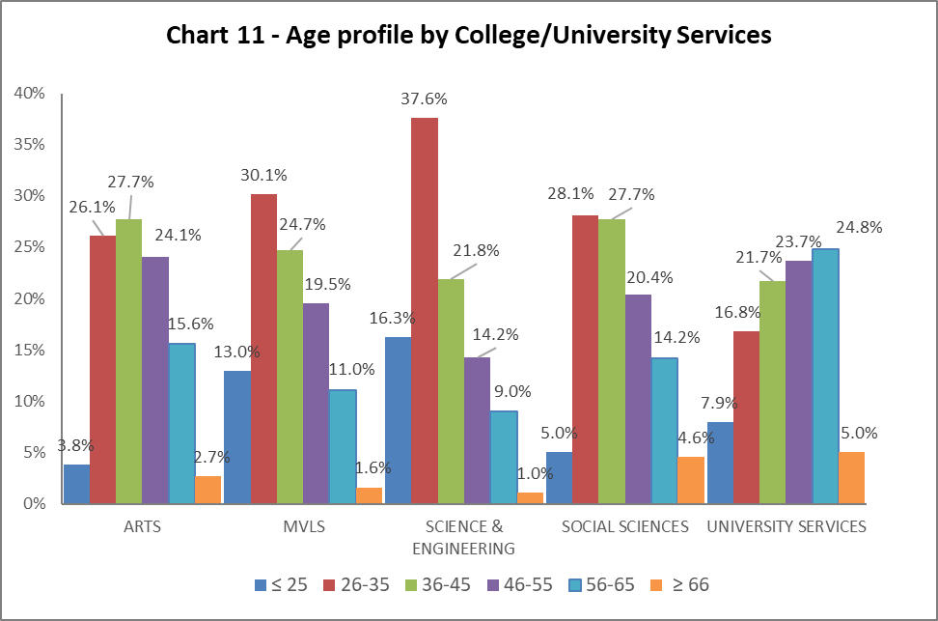

Table 7 | ARTS | MVLS | SCIENCE & ENGINEERING | SOCIAL SCIENCES | UNIVERSITY SERVICES
Age Range | % | % | % | % | %
≤ 25 | 3.8 | 13.0 | 16.3 | 5.0 | 7.9
26-35 | 26.1 | 30.1 | 37.6 | 28.1 | 16.8
36-45 | 27.7 | 24.7 | 21.8 | 27.7 | 24.2
46-55 | 24.1 | 19.5 | 14.2 | 20.4 | 20.0
56-65 | 15.6 | 11.0 | 9.0 | 14.2 | 14.8
≥ 66 | 2.7 | 1.6 | 1.0 | 4.6 | 2.9

Chart 11 above is visualisation of the distribution of ages in each College/US which can be compared with the Whole University distribution in Chart 1. Table 7 above gives the relevant percentages. All the Colleges have seen an increase in 26–35-year-olds. Arts is the only College where the majority of colleagues are older, in the 36-45 age bracket. University Services continues to have the oldest age profile, with most colleagues in the 56-65 years old, and the highest number of colleagues working who are over 66.

By Grade 10 staff
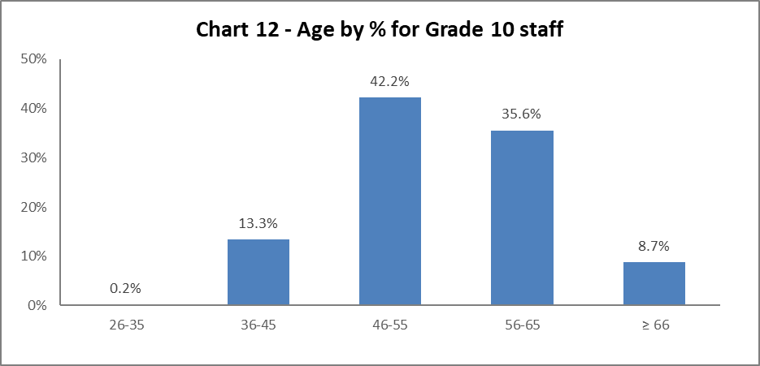

Chart 12 above shows most Grade 10 colleagues are aged 46 or over. Since 2019-20 there has been a 2.3% increase in colleagues in 56-65 age bracket, and a decrease by 2.2% in colleagues in the 36-45 age bracket.

By Job Family Profile
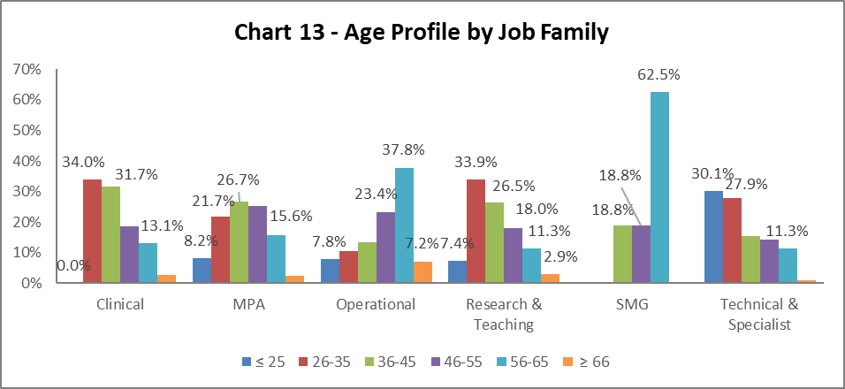

Table 8 | Clinical | MPA | Operational | Research & Teaching | SMG | Technical & Related
Age Range | % | % | % | % | % | %
Age ≤25 | 0.0 | 8.2 | 7.8 | 7.4 | 0.0 | 30.1
Age 26-35 | 34.0 | 21.7 | 10.5 | 33.9 | 0.0 | 27.9
Age 36-45 | 31.7 | 26.7 | 13.4 | 26.5 | 18.8 | 15.4
Age 46-55 | 18.6 | 25.3 | 23.2 | 18.0 | 18.8 | 14.3
Age 56-65 | 13.1 | 15.6 | 37.8 | 11.3 | 62.5 | 11.3
Age ≥66 | 2.6 | 2.4 | 7.2 | 2.9 | 0.0 | 1.0
Chart 13 above outlines the age distribution by job family. All the job families have higher proportions of under 25-year-olds – this is most notable in the Technical and Related job family where there has been increase by over 8% since 2019-20. This is significant as this is an increase in this age range by almost 19% since 2018-19. The Operational job family continues to be oldest, with high proportions of staff in the 56-65 age range.

By Grade

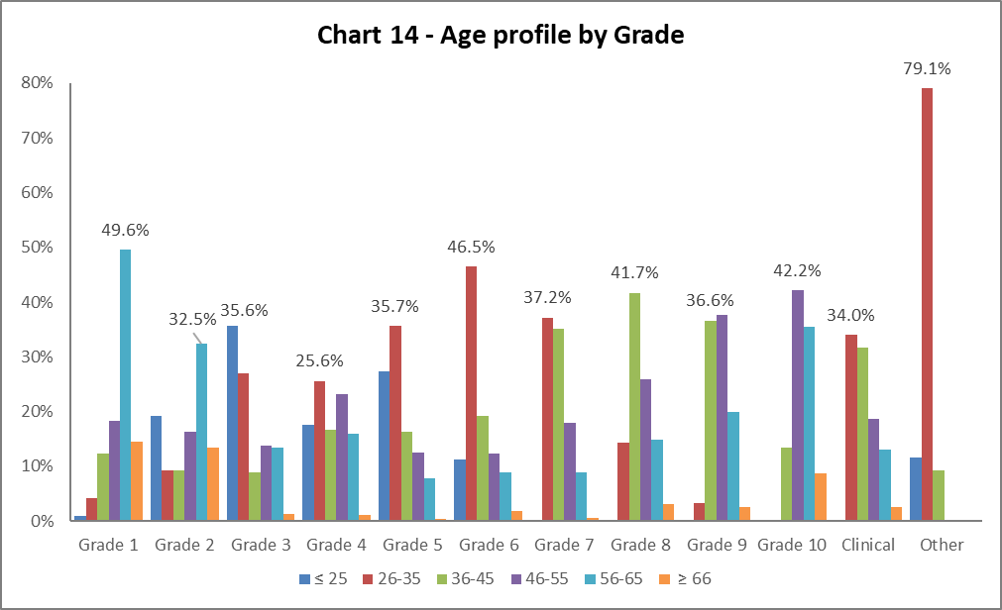

Table 9 | Grade 1 | Grade 2 | Grade 3 | Grade 4 | Grade 5 | Grade 6 | Grade 7 | Grade 8 | Grade 9 | Grade 10 | Clinical | Other
Age Range | % | % | % | % | % | % | % | % | % | % | % | %
Age ≤ 25 | 0.9 | 19.1 | 35.6 | 17.5 | 27.3 | 11.3 | 0.2 | 0.3 | 0.0 | 0.0 | 0.0 | 11.6
Age 26-35 | 4.3 | 9.3 | 27.0 | 25.6 | 35.7 | 46.5 | 37.2 | 14.3 | 3.2 | 0.2 | 34.0 | 79.1
Age 36-45 | 12.4 | 9.3 | 8.9 | 16.6 | 16.3 | 19.2 | 35.1 | 41.7 | 36.6 | 13.3 | 31.7 | 9.3
Age 46-55 | 18.4 | 16.4 | 13.8 | 23.2 | 12.5 | 12.3 | 17.9 | 25.8 | 37.6 | 42.2 | 18.6 | 0.0
Age 56-65 | 49.6 | 32.5 | 13.4 | 16.0 | 7.9 | 8.8 | 9.0 | 14.8 | 14.8 | 35.6 | 13.1 | 0.0
Age ≥ 66 | 14.5 | 13.4 | 1.3 | 1.1 | 0.3 | 1.9 | 0.6 | 3.2 | 3.2 | 8.7 | 2.6 | 0.0

Chart 14 and Table 9 show the grade profile for age range reflects the norm and has not changed significantly. However, there are increases in over 66-year-olds in Grades 1 and 2 by 3% and 2.7% respectively since 2019-20. The majority of 26–35-year-olds are in Grade 5 and 6 – the latter reflecting the start of the Research and Teaching job family.

By Full/Part Time

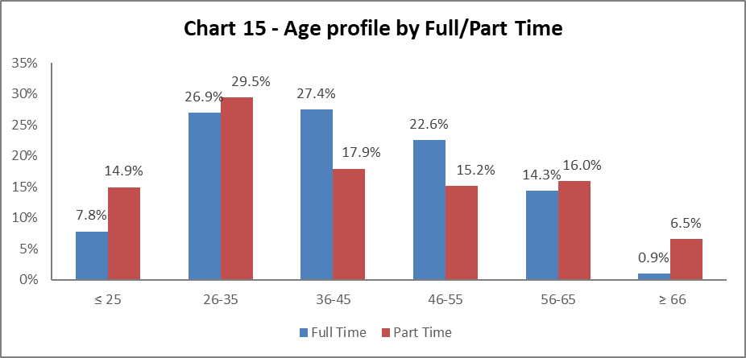

Chart 15 shows the part time staff age profile. A larger proportion of staff under 35 work part time than full time – this has grown by 2.3% in the 26-35 years old since 2019-20.

By Contract Type

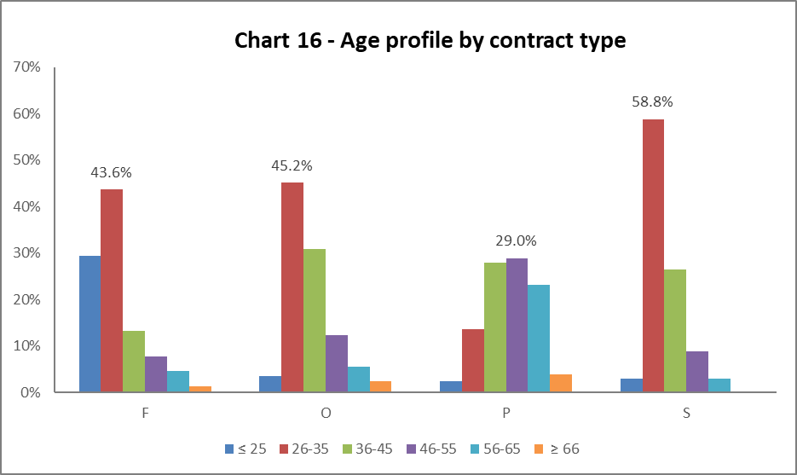

Key
F = Fixed term as per FT & OE Contract policy
O = Open ended with funding end date
P = Open ended (‘Permanent’) + Perm in Temp Fixed Term Appointment (HoC/Principal/VP role)
S = Fixed term - SOSR e.g. Maternity leave cover

Table 10 | F | O | P | S
Age Range | % | % | % | %
Age ≤25 | 29.4 | 3.5 | 2.4 | 2.9
Age 26-35 | 43.6 | 45.2 | 13.6 | 58.8
Age 36-45 | 13.2 | 30.9 | 28.0 | 26.5
Age 46-55 | 7.7 | 12.4 | 29.0 | 8.8
Age 56-65 | 4.7 | 5.5 | 23.2 | 2.9
Age ≥66 | 1.3 | 2.5 | 3.9 | 0.0

Chart 16 above shows that Open ended with Funding End Date (code O) and both types of Fixed Term (F & S) workers are generally younger (under 35). The data reflects 2019-20, with only minor fluctuations in the percentages. Younger colleagues are less likely to have permanent contracts.

By Nationality

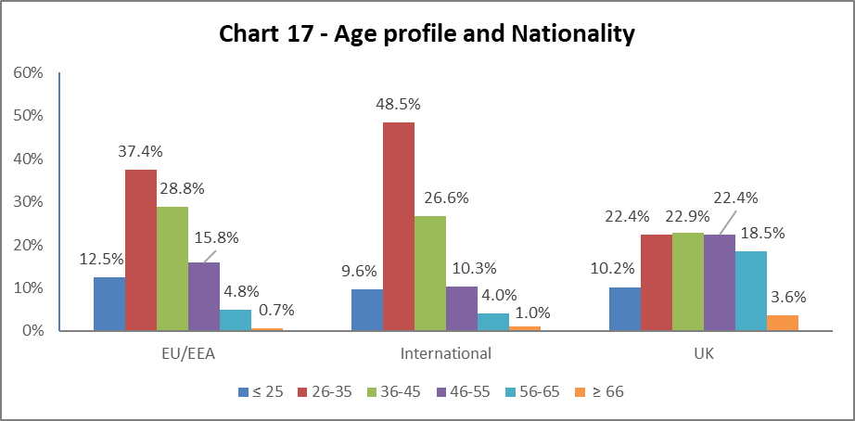

Chart 17 shows a higher percentage of our EU/EEA and International staff are younger than our UK staff, this reflects the last five years data.

Recruitment – by Applications and Successful Applicants
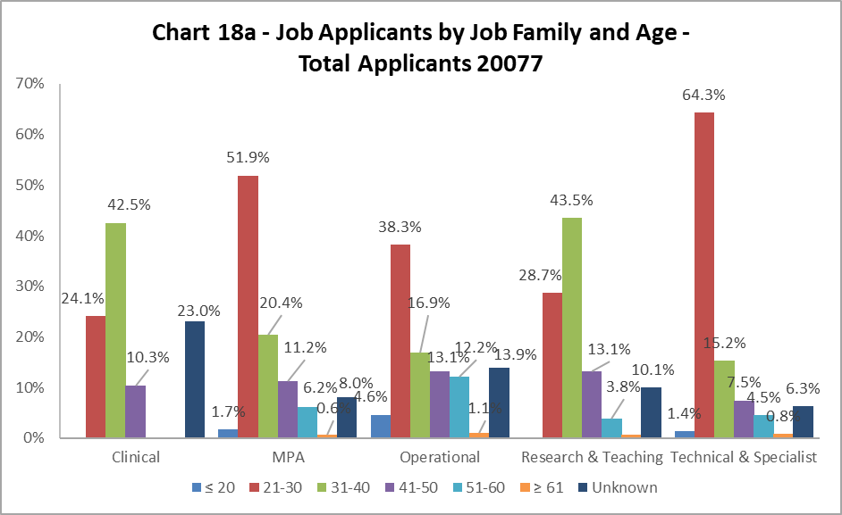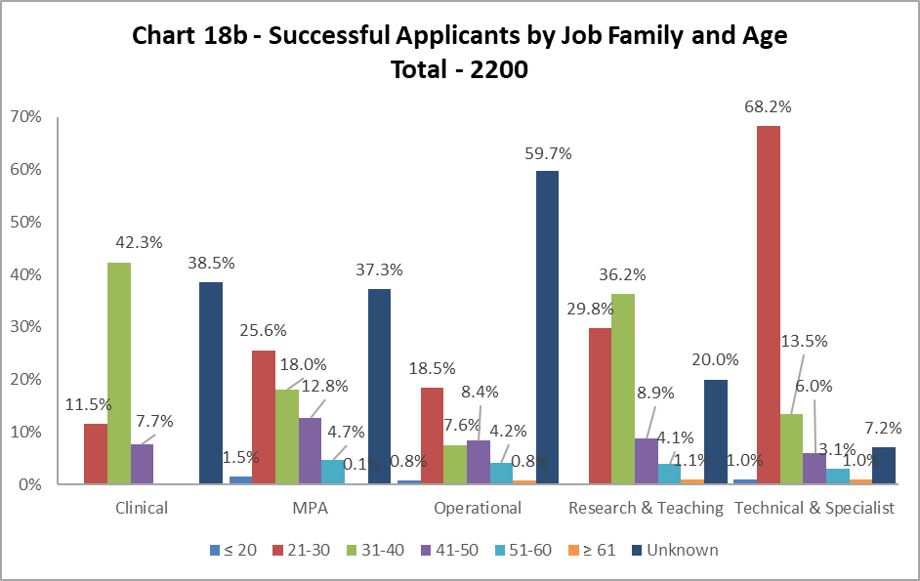

Charts 18a and 18b show the age of applicants and those who are successful. The biggest disparities are in the MPA and Operational job family, where under 30 have significant numbers of applications, but far fewer successful appointments. The opposite is true in Technical and Specialist roles, where under 30’s are more successful in gaining appointments. It should be noted there are significantly higher percentages of ‘Unknown’ in this data set – see notes section on page 5.

Profile by Disability

By College

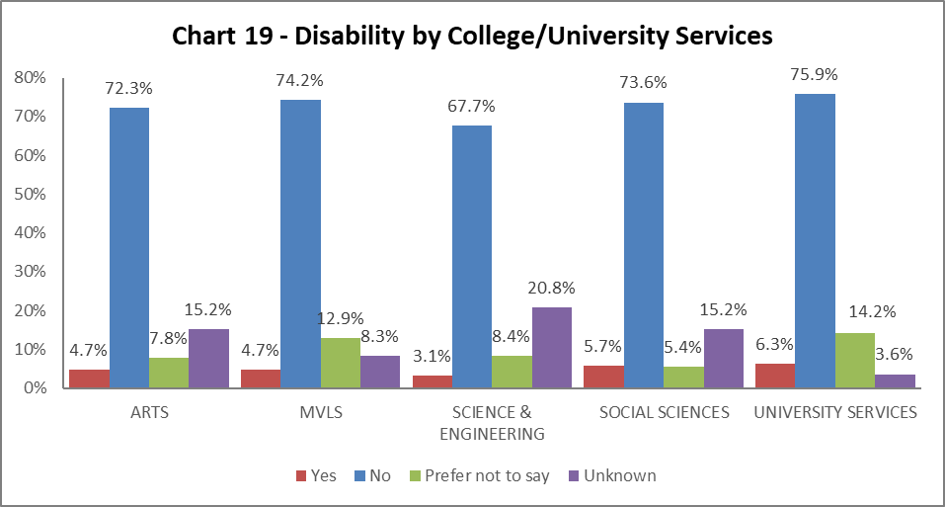

Chart 19 shows the percentage of disabled staff within College/US. All Colleges/US have seen an increase in declaration rates – this is 1% or more in Social Sciences and US, with smaller increases in the other three (only by 0.1% in Science and Engineering). There has been a drop in the percentage of ‘Unknown’ data in all Colleges and US, and a reflective increase in ‘Prefer not to say’.

By Grade 10 staff

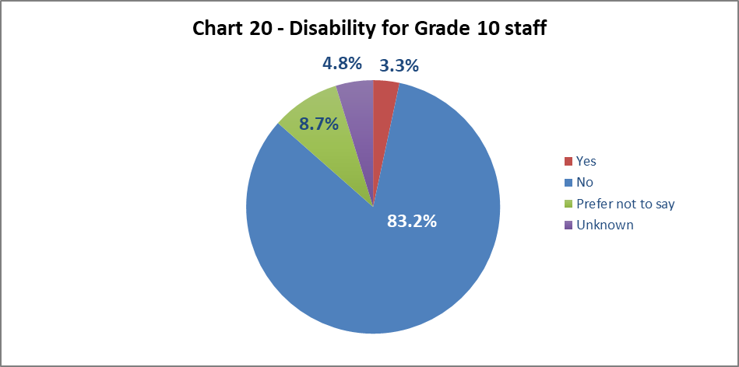

Chart 20 shows 3.3% of senior staff have declared a disability; this is a 0.7% decrease from 2019-20 and is lower than the University wide figures.

By Job Family Profile

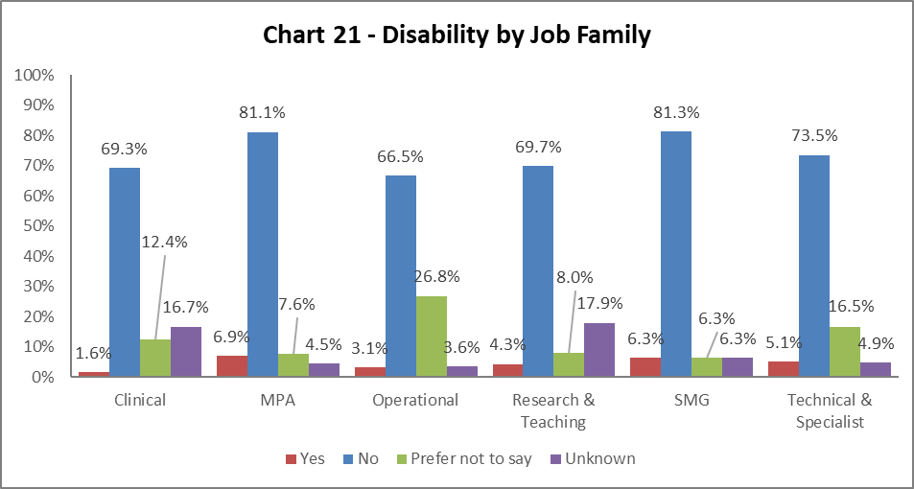

Chart 21 shows most job families have seen increases disability declaration rates from 2019-20. Most notable is the 1% increase in MPA and 0.6% in Research and Teaching colleagues declaring a disability. Reflecting other data sets, ‘Unknown’ figures have gone down, and ‘Prefer not to say’ categories have increased.

By Grade

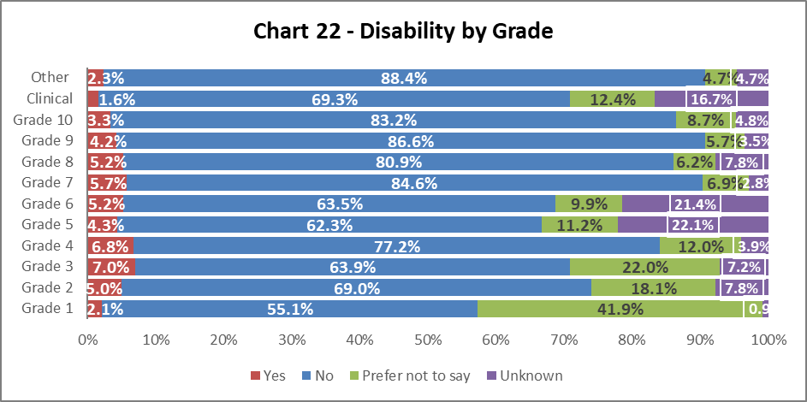

Chart 22 shows disability declaration rates by Grade. There has been little or no changes in Grades 1-2, drops in declaration rates in Grades 3-4 (by 0.4% and 1.1% respectively) and an increase in declaration rates from Grades 5-10, these are all by less than 1%. This reflects other data sets, where ‘Unknown’ has decreased and ‘Prefer not to say’ categories have increased.

By Full/Part Time

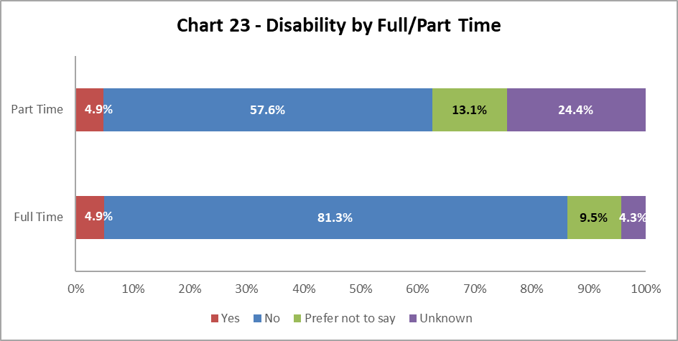

Chart 23 shows staff with a disability are equally as likely to work full time or part time.

By Contract Type

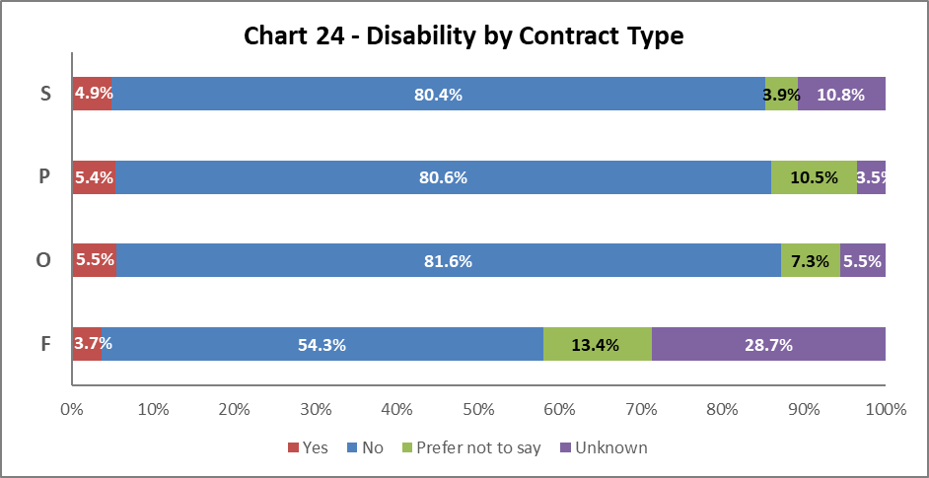

Chart 24 above shows disabled staff are most likely to have an Open Ended with Funding end data (Code O) or a Permanent (Code P) contract. This is a change to 2019-20, where they were most likely to have SOSR (Code S) contract. There has been a 0.9% increase in colleagues on a Permanent contract (Code P), a 0.2% in colleagues on an Open-ended with ending fund date (Code O), a 0.5% increase in colleagues with Fixed Term contract (Code F) and a reduction by 3.1% in colleagues on a SOSR (Code S) with a declared disability since 2019-20. Reflecting other data sets there has been a reduction in ‘Unknown’ categories and an increase in disability declarations rates, and those stating ‘Prefer not to say’.

By Nationality

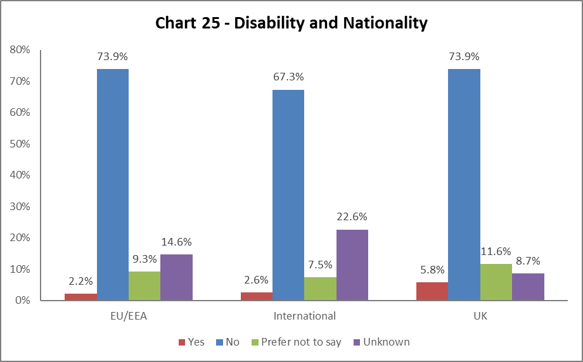

Chart 25 indicates a higher percentage of staff from the UK have declared a disability, however all nationalities have seen an increase in colleagues declared disability rates since 2019-20.

BSL Users

As part of the University’s British Sign Language (BSL) Action Plan we have reviewed the number of staff who declared a level of proficiency in the use of BSL. 16 staff, a three-fold increase on the previous report, have declared a level of proficiency.

Recruitment – by Applications and Successful Applicants
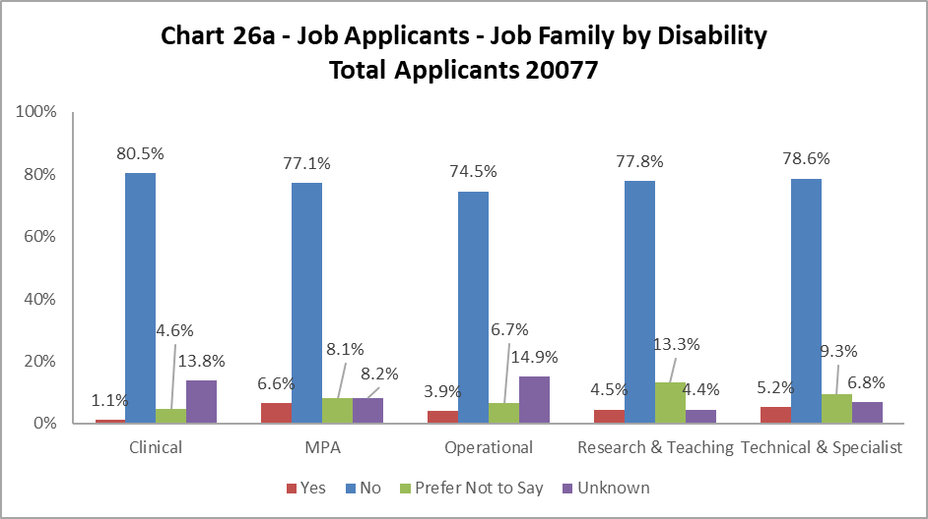

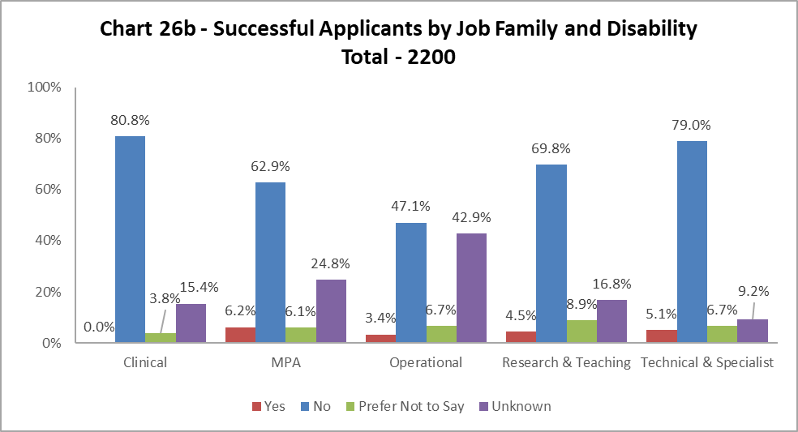

Charts 26a and 26b show that across most job families had slightly more disabled applicants than were successfully appointed, however the differences were very small, this reflects 2019-20. The only exception was Clinical where no disabled staff were successful, however the numbers will be small in this job family. It should be noted there are significantly higher percentages of ‘Unknown’ in this data set – see notes section on page 5.

Profile by Ethnicity

By College

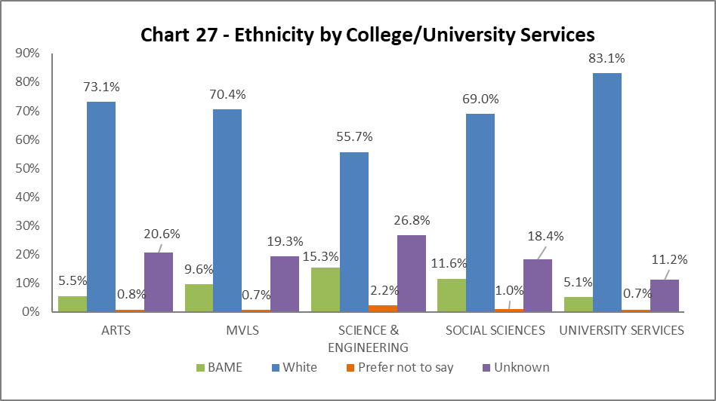
Chart 27 shows the breakdown by ethnicity of staff in College/US. There have been increases in the percentages of ethnic minority staff across all Colleges/US – most notably in Arts (a rise of 0.6%), MVLS (rising by 1.6%), Science and Engineering (rising by 1.1%) and US (rising by 0.5%). The percentages of colleagues with ‘Unknown’ ethnicity continues to rise across all areas, except US.

By Grade 10 Staff

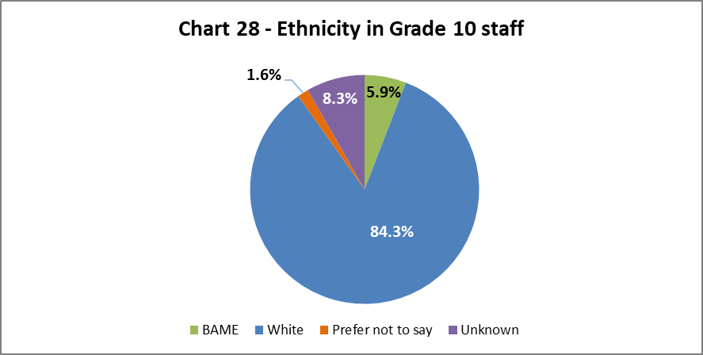

Chart 28 above show the ethnicity of staff at Grade 10. The has been a minor increase in BAME staff at this grade from 5.4% in 2018-19 to 5.9% in 2020-21.

By Job Family Profile
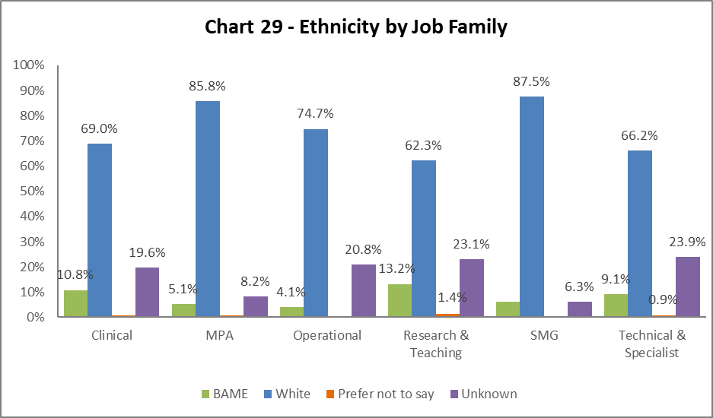

Chart 29 shows the ethnicity of staff by job family. There have only been minor fluctuations in BAME staff across the job families since 2019-20. The exception is Technical and Specialist roles, which have seen a 4.1% increase in BAME colleagues since 2019-20. Notably, there are high percentages of ‘Unknown’ across all the job families, with only MPA and Clinical staff recording a fall in this from 2019-20.

By Grade

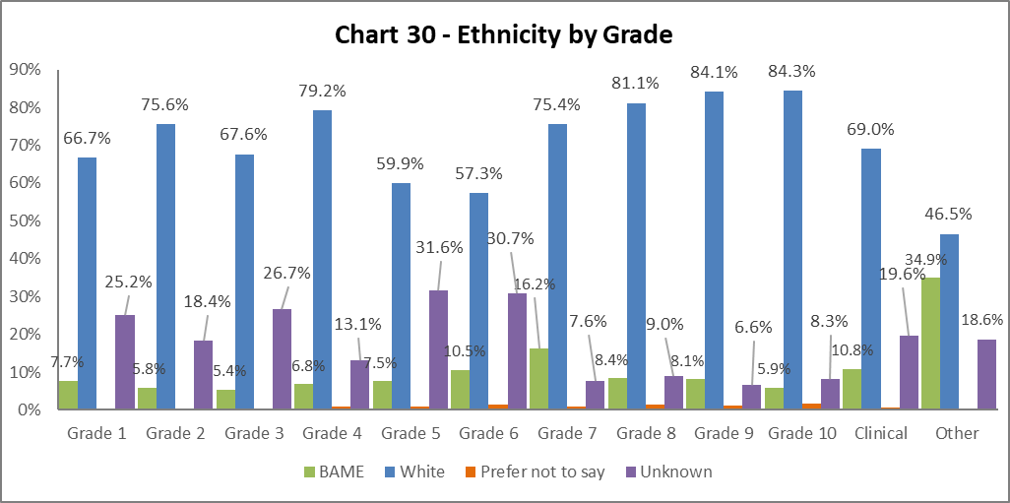

Chart 30 above shows the grade and ethnicities of staff. There is a differing picture across the grades, with drops in the percentages of BAME colleagues in Grades 1-5 compared and increases in the percentages from Grades 6-10 between 2019-20 and 2020-21. There are notable drops in the percentages of ‘Unknown’ in Grades 1-5 and increases in Grades 6-8 from the previous year.

By Full/Part Time

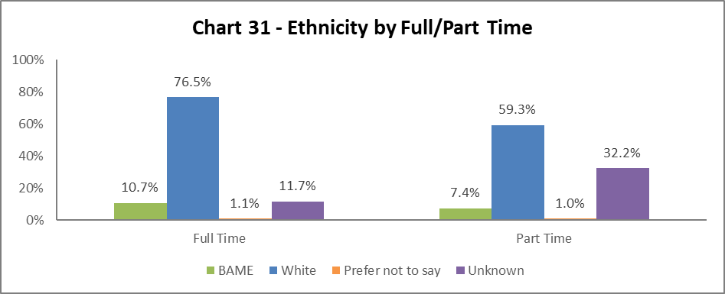

The ethnicity of staff working full time and part time reflects the 2019-20 data, however there are rises in the ‘Unknown’ category for both modes of working.

By Contract Type

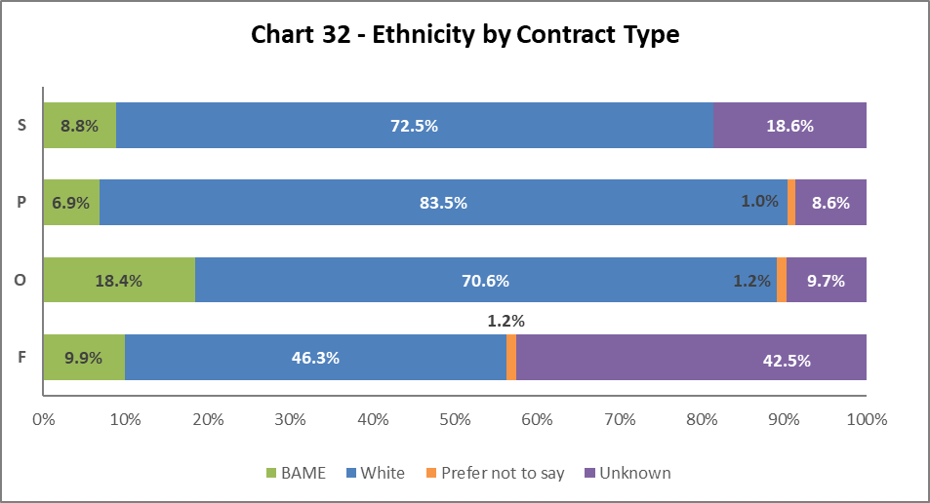

Chart 32 indicates the highest proportion of BAME staff are on Open-ended with funding end date (code O) contracts, an increase of 4.4% from 2017-18. All the other contract types (S,O,F) have seen an increase of BAME colleagues from 2019-20.

By Nationality

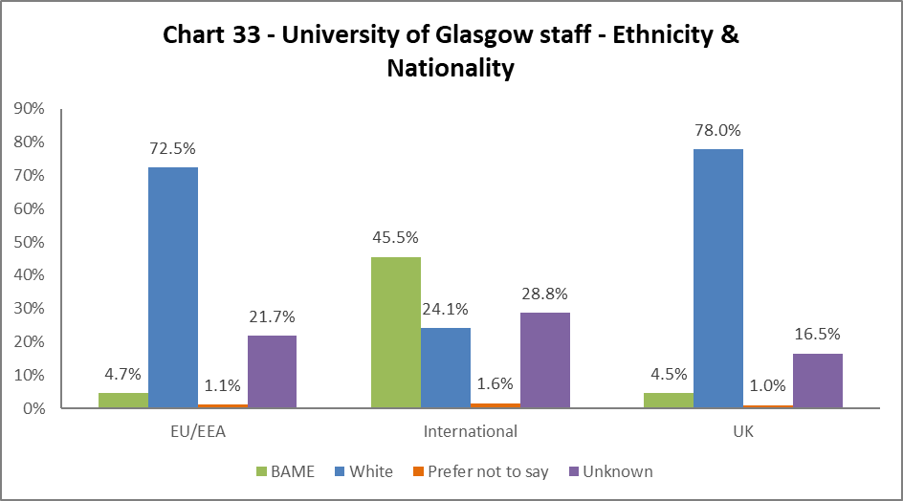

Chart 33 outlines the nationality and ethnicity of our staff. 45.5% of our International and 4.7% of our EU/EAA colleagues are from BAME backgrounds. Of our UK staff, only 4.5% are from BAME backgrounds – however this is an increase of 0.4% from 2019-20.

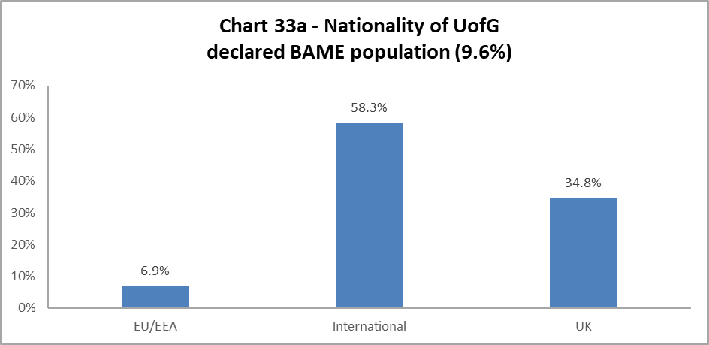

Chart 33a outlines the nationality of our whole BAME staff population (9.6% of total – see Chart 6a). Over half of our total BAME colleagues are International, an increase of 2.2% from 2019-20. A third from the UK (a slight drop of 0.5% from 2019-20) and 6.9% from the EU/EEA (a drop of 1.6% from 2019-20).

Recruitment – by Applications and Successful Applicants

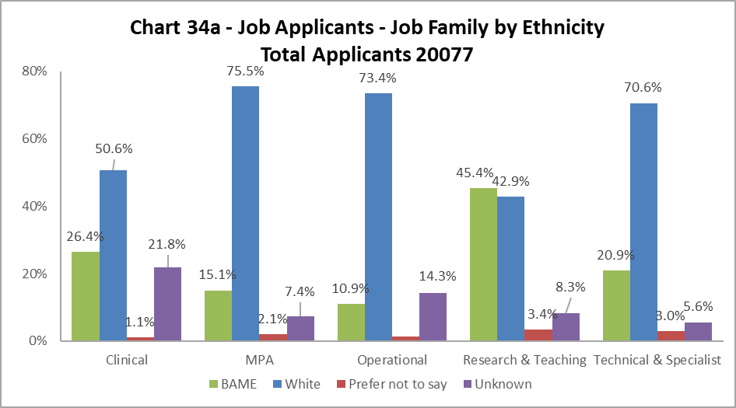

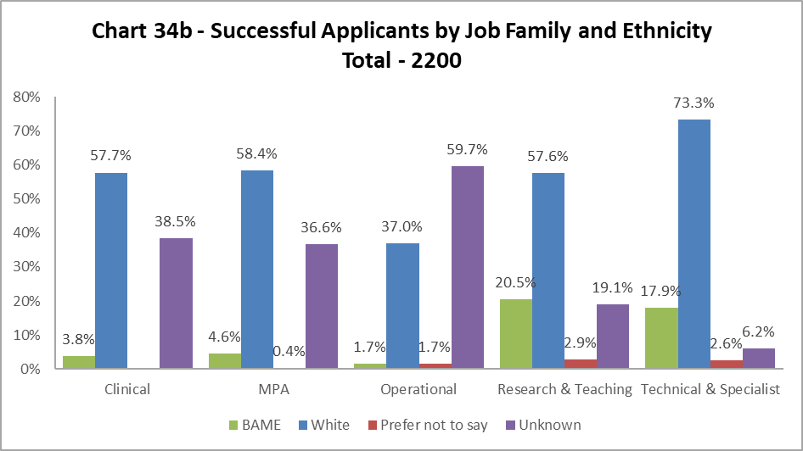

The data, as illustrated by Chart 34a and 34b, shows BAME staff are proportionally less likely to be appointed in all job family profiles. The greatest difference is seen in the Clinical and Research and Teaching job family, where the drop between applications and successful applicants is over 20% - it should be noted there will be a relatively low number of jobs advertised in the Clinical job family. The drop seen in Operational jobs is a reversal from 2019-20, where the successful applicants were much closer to the number of applicants. The outlier in 2020-21 is Technical and Specialist roles – where there is only a 3% drop between the percentage of BAME applications and successful applicants. It should be noted there are significantly higher percentages of ‘Unknown’ in this data set – see notes section on page 5.

Profile by Sex

By College

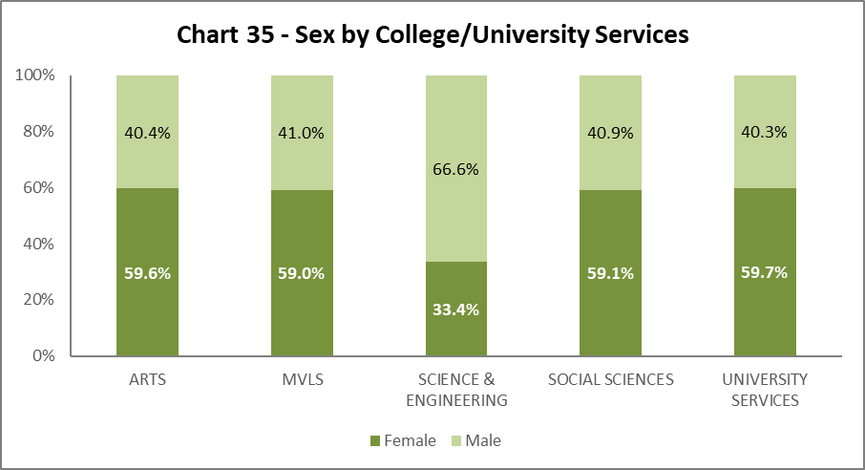

Chart 35 shows the split by Sex in College/US. Arts, Social Sciences and University Services have seen a slight drop in the percentage of Males, whilst MVLS has had an increase. Science and Engineering has had a slight drop in the percentage of Females (by 0.4%).

By Grade 10 Staff

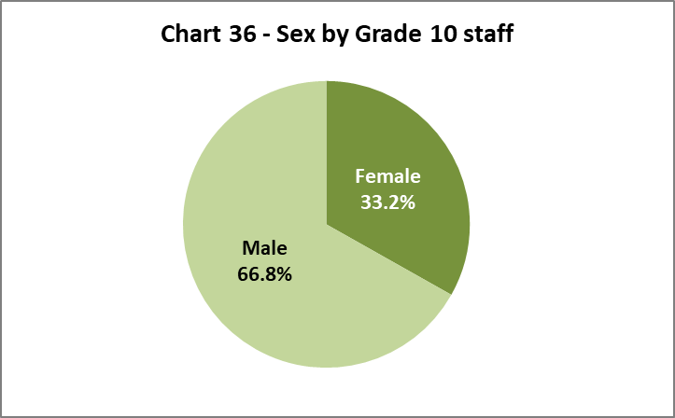

Chart 36 illustrates that 33.2% of senior staff are Female.

By Job Family Profile

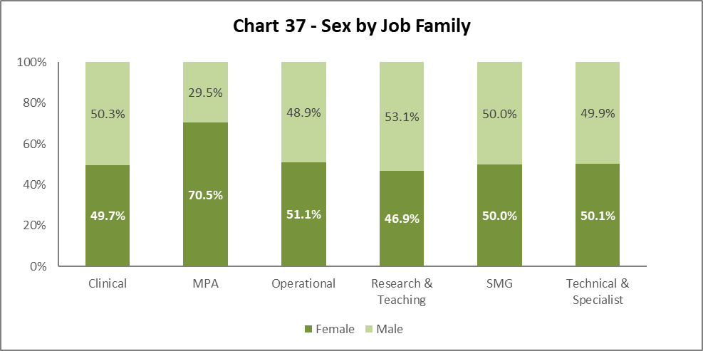

Chart 37 shows SMG is 50/50 Female to Male in 2020-21. There are other minor fluctuations across the job families – an increase in females in Clinical and MPA job families.

By Grade

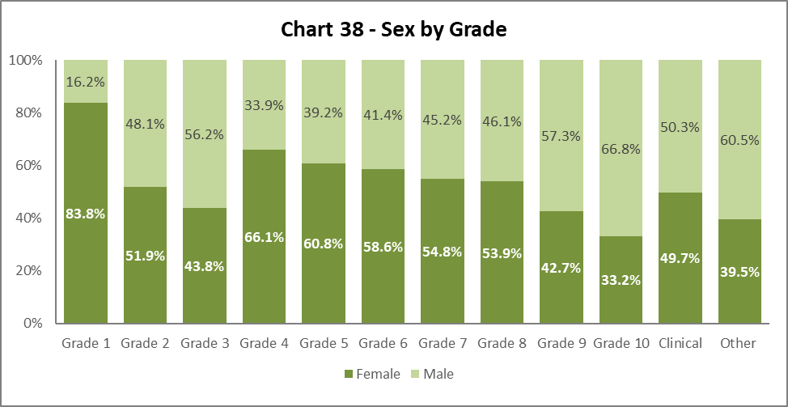

Chart 38 shows there are more Females in Grades 1, 2, 4 (a decrease of 2.7% from 2019-20), 5, 6, 7, and 8. Males are higher in Grades 3 (an increase of 2.8%), 9 and 10. This is similar pattern to previous years as we climb the grades, the percentage of Male staff increases, and Female staff declines.

By Full/Part Time

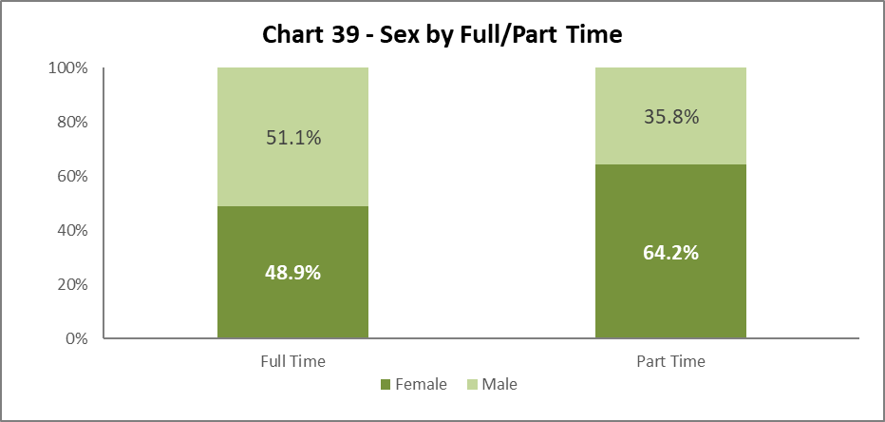

Chart 39 illustrates the breakdown by Sex of Full and Part Time staff, this is a static picture from 2019-20, where approximately two thirds of all Part Time staff are Female.

By Contract Type

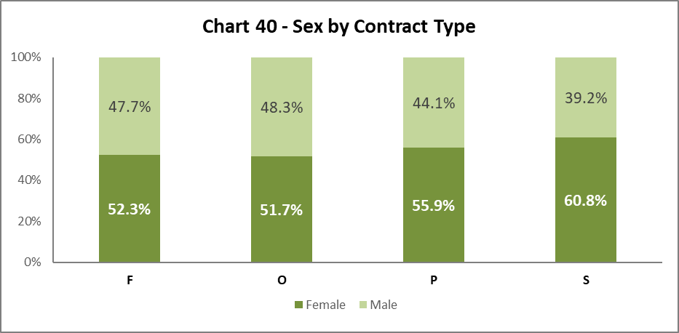

Chart 40 shows Sex by contract type. There has been little change from 2019-20, except in contract type S, where there has been a 7.8% increase in Females on this contract type.

By Nationality

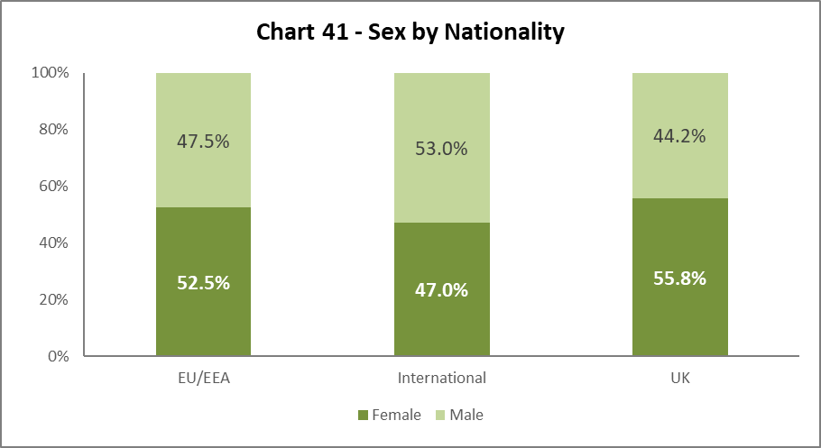

Chart 41 shows a similar picture to 2019-20; Females and Males are equally represented from EU/EEA. We have a higher proportion of Male International staff, although the Female representation has increased by 1.5% since 2019-20.

Recruitment – by Applications and Successful Applicants

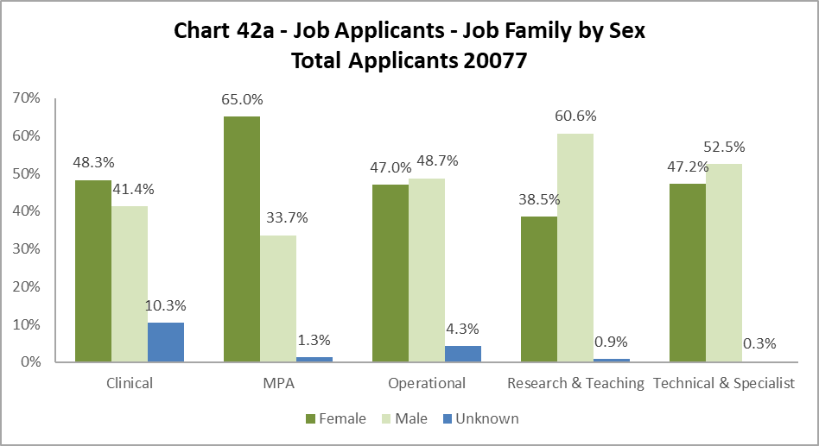

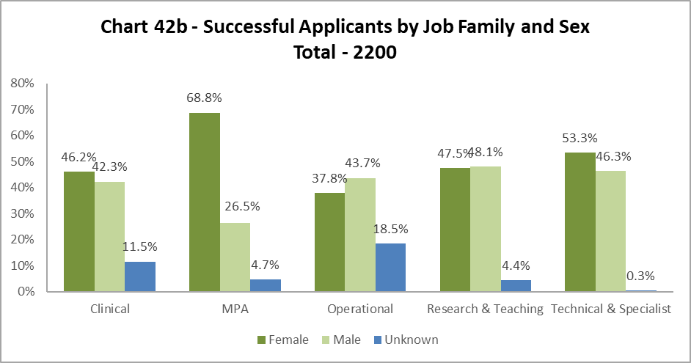

Charts 42a and b indicate Females are usually more successful than Males. This is notable in job families MPA, Research and Teaching and Technical and Specialist compared to the percentage of applicants. It should be noted there are significantly higher percentages of ‘Unknown’ in this data set – see notes section on page 5.

Profile by Sexual Orientation

33.0% of all staff have not answered the question on Sexual Orientation. As such ‘Unknown’ figures have been excluded from these graphics but have been included in the statistics which are used to create them.

By College

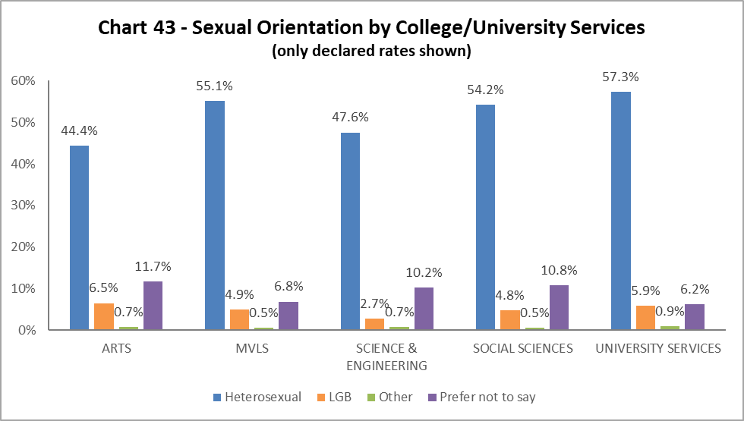

Chart 43 outlines the percentage of colleagues who have declared their LGB status. All Colleges/US, except Science and Engineering, have seen an increase since 2019-20. The highest is in Arts and MVLS (increased by 1.2%), followed by US (1.1% increase) and Social Sciences (0.7% increase). Science and Engineering has seen a minor drop of 0.1% since 2019-20.

By Grade 10 Staff

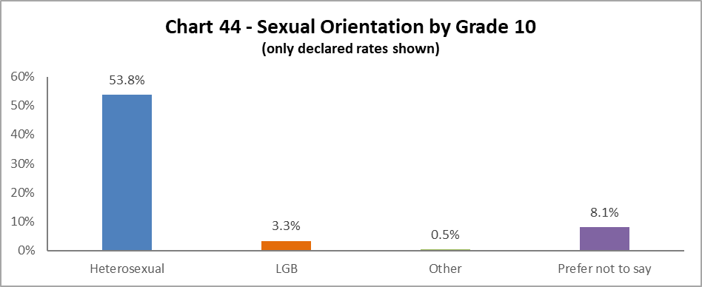

3.3% of Grade 10 staff identify as LGB, this is static from 2019-20.

By Job Family

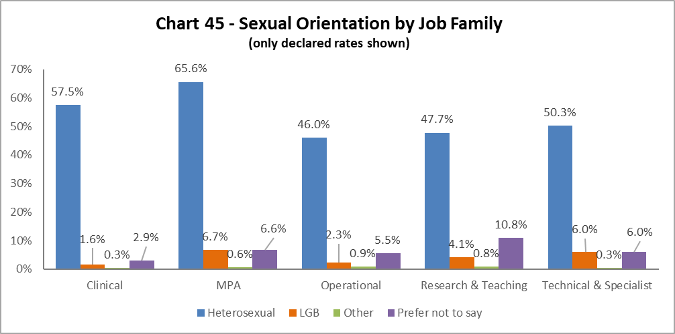

The highest proportion of LGB staff (6.7%) are in the MPA job family, an increase of 3% from 2017-18. There has also been a notable rise in the percentage of Technical and Specialist LGB colleagues, an increase of 2.4% from 2019-20.

By Grade

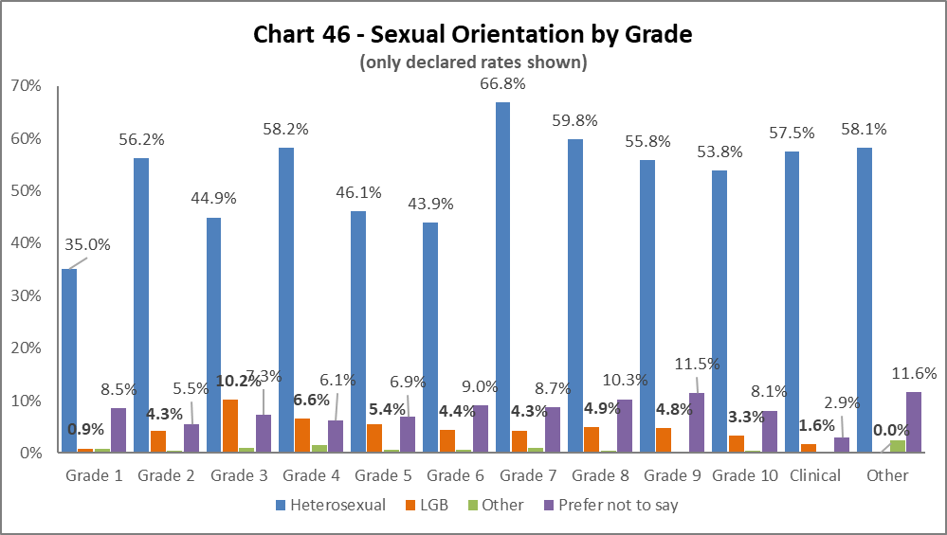

LGB staff are evenly spread across the grades, with the highest proportion in Grade 3, an increase of 4.6% from 2019-20. There have been slight fluctuations across the grades, with increases recorded in Grades 2, 4, 5, 6, 8, and 9.

By Full/Part Time

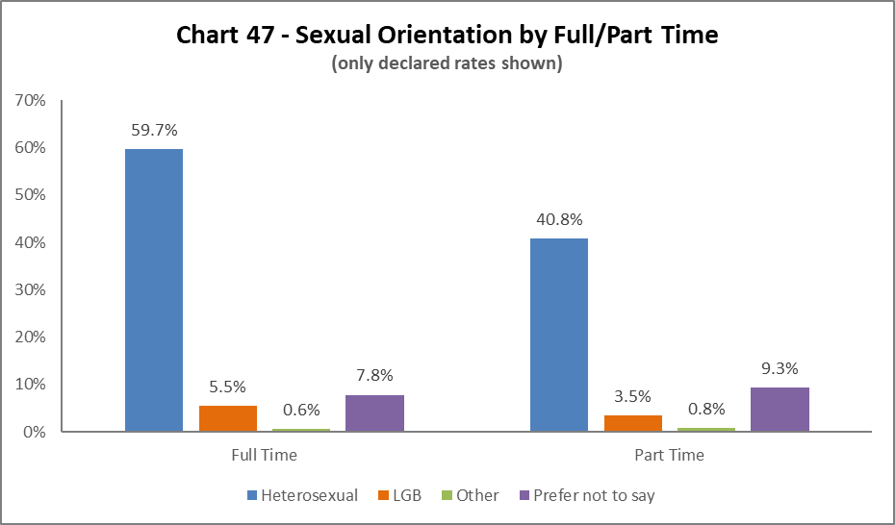

Most LGB staff work Full Time, an increase of 0.8% from 2019-20, however there has also been an increase in LGB staff working Part Time, by 0.7% from 2019-20.

By Contrast Type

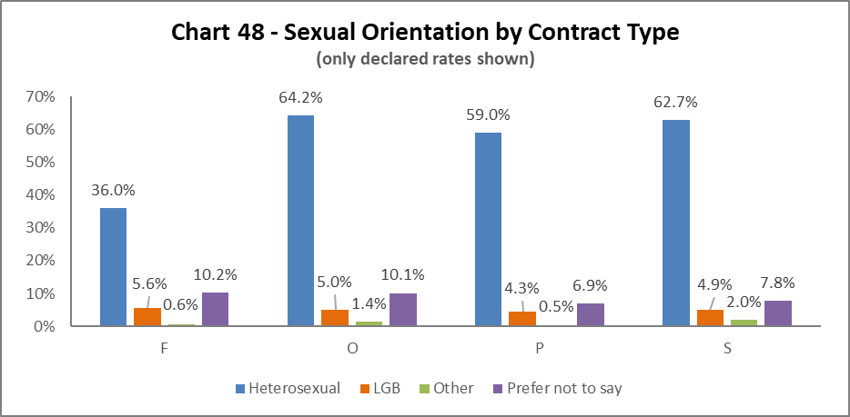
The highest proportion of LGB staff are those on the Fixed term (code F) contracts, however this is a very small percentage of staff. The next highest are on Open ended with funding end dates (O), this is static from 2019-20. The lowest proportion are on Open Ended (code P) contracts, however this has increase from 0.6% in 2019-20.

By Nationality
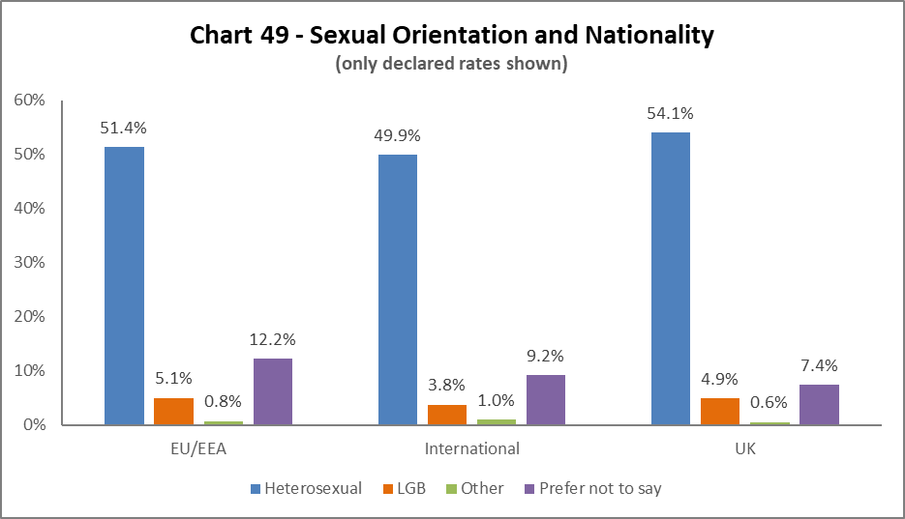
The highest proportion of LGB staff are from the EU/EEA, a 1% increase from 2019-20. There has been a 0.9% increase in UK and 0.2% increase in International LGB colleagues since 2019-20.

Recruitment – by Applications and Successful Applicants

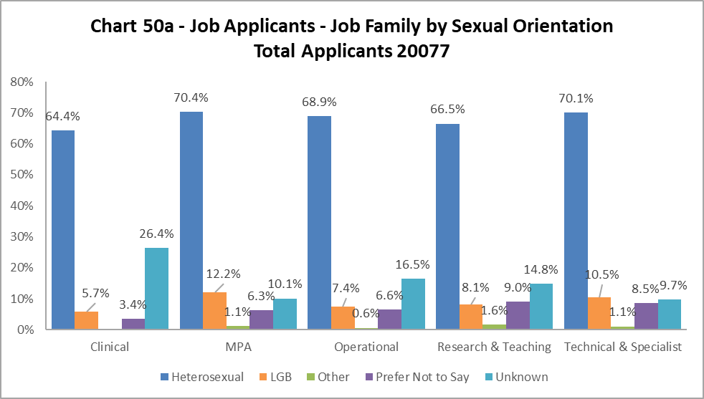
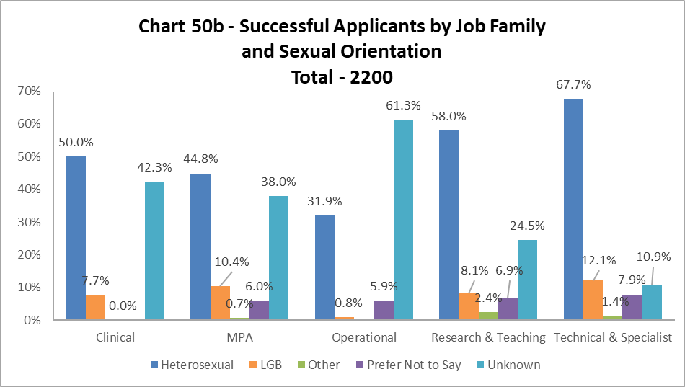
The proportion of successful LGB applicants closely matches that of the applicant pool across the job families, with the exception of Operational staff, where this dropped by 6.6%. It should be noted there are significantly higher percentages of ‘Unknown’ in this data set – see notes section on page 5.

Case Management – General

2020-21 saw a significant increase in the number of Case Management cases – 103, compared to 61 cases in 2018-19 and 33 in 2019-20.

Chart 51a A higher percentage of Managing Attendance cases were Females, but this is a considerable drop from 2019-20, where 81.8% were Females. Males were significantly more likely to be taken through a Disciplinary process – a change from 2019-20, where this was more even between the sexes. In 2019-20, Females were more likely to take a Grievance (76.9%) – this is more even between the sexes in 2020-21.

Chart 51b, considering the ethnicity of staff involved in case management, and is included for the first time in this report. With 9.6% of colleagues from a BAME background, those involved in Managing Attendance, Discipline or Grievances is lower than the University population.
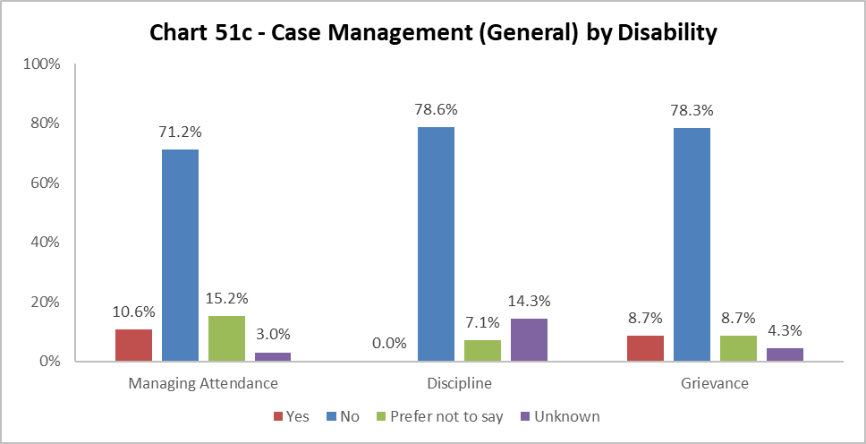

Chart 51c, considers the disability status of colleagues involved in case management cases, and is included in this report for the first time.

As the University population of disabled colleagues is 4.9%, double this proportion are involved in Managing Attendance processes and a higher proportion of disabled colleagues are involved in Grievances. It should be noted a high proportion of colleagues involved in case management respond prefer not to say to this question. As this is the first year of considering this data set, we would need to look at future years to see any patterns.

Case Management – Sickness

The sickness figures relate to staff who have been absent for 20 or more continuous working days between 01 August 2020 – 31 July 2021. This involves 3.9% of staff under report. This is a reduction from 2019-20.

Age

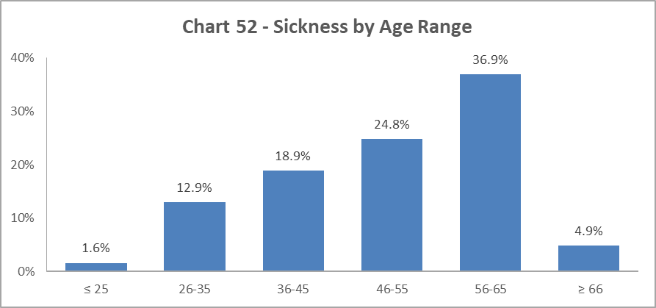

Chart 52 shows most staff who were off sick for 20 days or more, were in the 56-65 age group. This a change from 2019-20, where the majority were 46-55 age range.

Disability

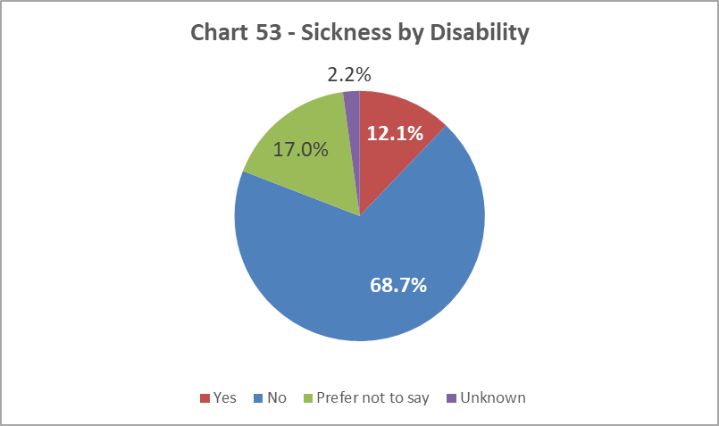

Chart 53 shows the proportion of disabled staff absent for 20 days or more was 12.1%, which represents an increase of 2.9% from 2019-20. This reflects a continuous rise from 2.9% in 2013-14. There is a notably high percentage of staff who chose the ‘Prefer not to say’ category.

Ethnicity

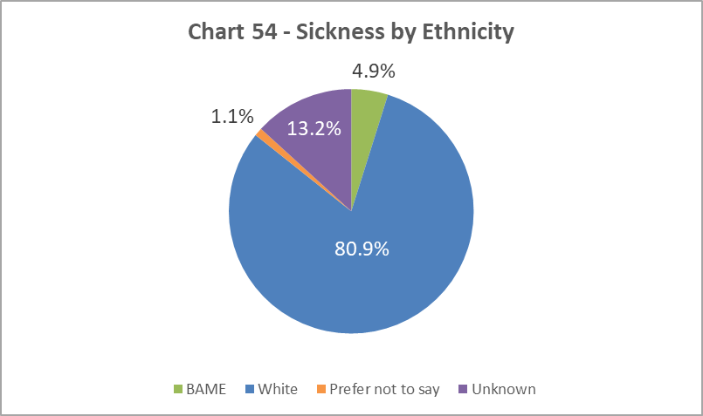

Chart 54 shows that, of staff who were off sick for more than 20 days, 4.9% are from a BAME background; this is a 0.4% decrease from 2019-20. A relatively high percentage of staff who were off for 20 days have unknown ethnicity.

Sex

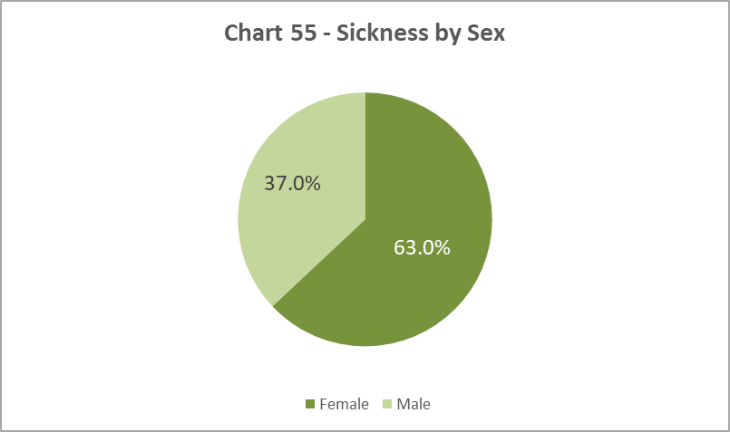

As in previous years, a higher proportion of Female staff have been off sick for 20 days or more than the overall University population as illustrated in Chart 8. However, this is a decrease of 2.3% from 2019-20.

Sexual Orientation

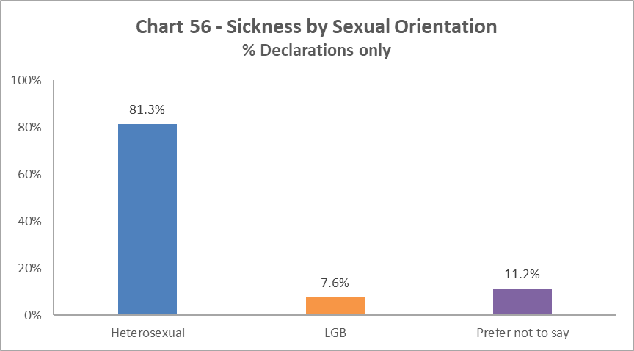

Chart 56 shows that of those who were off sick for more than 20 days, 7.6% declared as LGB. This is an increase of 3.2% from 2019-20.

Academic Promotions

Table 11 - Academic Promotions 2021 - R&T and Clinical Job Families Only
Grade Applied For |  | Success Rate  For Grade | Female | Male
GRADE 7 | Applicants |  | 49% | 51%
 | Successful |  | 48% | 52%
 | Promoted (%) | 86% | 84% | 88%
GRADE 8 | Applicants |  | 46% | 54%
 | Successful |  | 48% | 52%
 | Promoted (%) | 96% | 100% | 92%
GRADE 9 | Applicants |  | 55% | 45%
 | Successful |  | 52% | 43%
 | Promoted (%) | 76% | 79% | 72%
READER | Applicants |  | 33% | 67%
 | Successful |  | 42% | 58%
 | Promoted (%) | 80% | 100% | 70%
CLINICAL | Applicants |  | 50% | 50%
 | Successful |  | 43% | 57%
 | Promoted (%) | 88% | 75% | 100%
PROFESSOR | Applicants |  | 43% | 57%
 | Successful |  | 39% | 61%
 | Promoted (%) | 66% | 60% | 70%
SUCCESS RATE FOR ALL APPLICANTS % |  | 81% | 82% | 80%

Table 11 provides breakdown by Sex of the Academic Promotions 2020-21 process. The overall success rate is higher for Females than Males. However, Females have been more successful in 2020-21 in Grades 8, 9 and Reader, and Males in Grades 7, Clinical and Professors.

Regrading for Professional & Support Staff

Table 12 - Regrading 2020-21 - Professional and Support Staff by Grade
Grade Applied For |  | Success Rate | Female | Male
GRADE 1-5 | Applicants |  | 82% | 18%
 | Successful |  | 82% | 18%
 | Promoted (%) | 100% | 100% | 100%
GRADE 6-10 | Applicants |  | 62% | 38%
 | Successful |  | 62% | 38%
 | Promoted (%) | 100% | 100% | 100%
SUCCESS RATE FOR ALL APPLICANTS % |  | 100% | 100% | 100%

Table 13 - Regrading 2020-21 - Professional and Support Staff by Job Family
Job Family |  | Success Rate | Female | Male
MPA | Applicants |  | 81% | 19%
 | Successful |  | 81% | 19%
 | Promoted (%) | 100% | 100% | 100%
OPERATIONAL | Applicants |  | 0% | 100%
 | Successful |  | 0% | 100%
 | Promoted (%) | 100% | 0% | 100%
TECH & SPEC | Applicants |  | 33% | 67%
 | Successful |  | 33% | 67%
 | Promoted (%) | 100% | 100% | 100%
SUCCESS RATE FOR ALL APPLICANTS % |  | 88% | 100% | 100%

Table 12 above shows all applications for regarding were successful in 2020-21.

Table 13 shows there were higher percentages of Females seeking regarding in MPA job families and higher percentages of Males in Technical and Specialists job families. No Females were considered for regrading in the operational job family.

Equal Pay
The University has a duty to publish pay gap information by 30th April every two years under Regulation 7 of the Equality Act 2010 (Specific Duties) (Scotland) Regulations 2012. The most recent Equal Pay reports for Gender, Ethnicity and Disability were published in April 2021.

END.

World Changers Together 2025
As in previous years, MRC staff have been removed from this category and reallocated to the relevant grade based on salary scales.

